DHAKA THURSDAY SEPTEMBER 26,

VOL. XXXIV No. 244

WWW.thedailystar.net

REGD. No. DA 781

Ashwin 11, 1431 BS

RABIUL AWAL 22, 1446 Hijri

20 PAGES PLUS RISING STAR:TK 15.00

**Sakib available, but concerns lie with batters**

**India allows foreign diplomats to observe J&K**

**Ctg sees surge in dengue**

**Interim govt speeds up Adani payments**

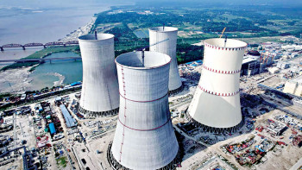

**RAFIV L ISIA.M and EMRUL IIASAN BAPP**

A man named Labhlu Mia was shot dead in the capital's Uttara during protests on the morning of August 5. A month later, his cousin Dukhu Mia, a rickshaw puller in the city, filed a murder case with Uttara Fast Police Station, accusing 221 people, 210 of whom are residents of Rangpur, the hometown of Dukhu and labhlu.

[***See page 2 Col 5***](https://www.thedailystar.net/news/bangladesh/news/dubious-cases-weaken-quest-justice-3708706)

"The ARMS is going to be delivered as a single package to the Rooppur NPP site. It will be used for the first time for the Rooppur project. The dosimeters and other individual dosimetry mean for the NPP personnel will be shipped to Bangladesh by the end of this year, but the main hardware will be already at hand at the project site by that time," he said.In addition, the software and hardware complex of a unique individual dosimetric monitoring system is already delivered to the site.

The state atomic energy corporation of Russia said the shipped cargo includes 23 units of ARMS for the plant -- 15 for unit-1 and eight for unit 2.ARMS is designed to collect, process, record, and display data on the radiation state parameters of the controlled objects.Nuclear power plants, nuclear fuel cycle enterprises, RAW storage and processing facilities, and scientific and research centers are equipped with these systems, according to the statement.

Twenty three units of automated radiation monitoring systems (ARMS) shipped from Russia for Rooppur Nuclear Power Plant are expected to be delivered to the project site shortly, Rosatom, the general designer and contractor of the power plant, said in a statement.

# **Rooppur power plant to receive equipment for radiation monitoring soon**

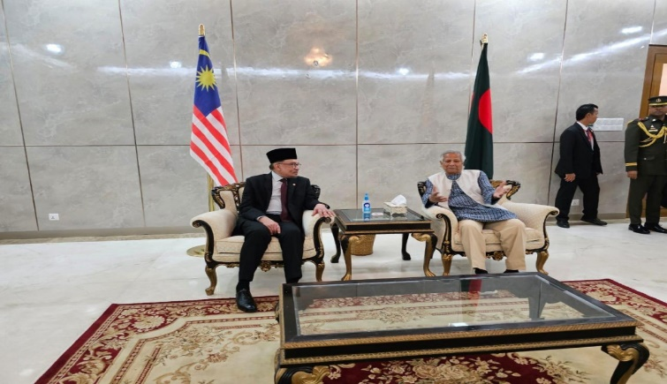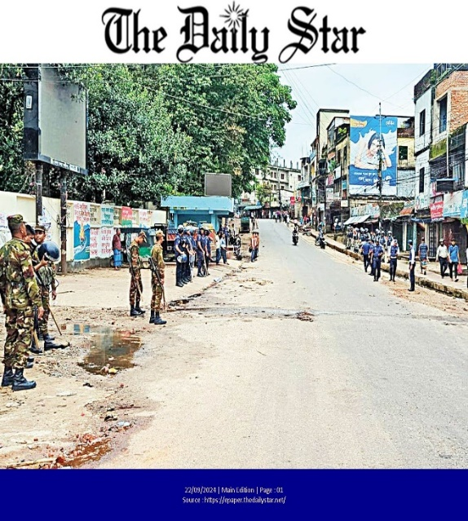

**

[***See page 2 Col 6***](https://www.thedailystar.net/environment/pollution/water-pollution/news/rivers-around-dhaka-stay-heavily-polluted-3708711)

Malaysian Prime Minister Anwar Ibrahim today promised to consider the issue of 18,000 Bangladeshi workers who missed a deadline to enter Malaysia saying that they need workers, but not "modern slaves"

* [Malaysian PM Anwar Ibrahim arrives in Dhaka](https://www.thedailystar.net/news/bangladesh/news/malaysian-pm-anwar-ibrahim-arrives-dhaka-3719571)
* [Yunus holds brief meeting with Malaysian PM at Dhaka airport](https://www.thedailystar.net/news/bangladesh/diplomacy/news/yunus-holds-brief-meeting-malaysian-pm-dhaka-airport-3719586)

### [Malaysia entry debacle / Anwar Ibrahim to consider issue of Bangladeshi workers](https://www.thedailystar.net/news/bangladesh/diplomacy/news/anwar-ibrahim-consider-issue-bangladeshi-workers-3719691)

The level of DO of the Buriganga river went as low as 0.1 mg/l at Bosila point in April 2022 while it went up to 6.26 mg/l in the monsoon in July at the Bangladesh China Friendship Bridge.

The monitoring involved field measurements and collecting water

samples for laboratory analyses to a total of 12 parameters

# Rivers around Dhaka stay heavily polluted

### *Finds the latest study by DoE*

**PINAKI ROY**

Rivers around Dhaka city remain seriously polluted despite some measures that have been taken over the years to curb water pollution, according to a recent study.

Solid wastes from polluting industries, municipal sewage and medical waste are polluting the rivers that surround major cities.